**Events (ECE)**

1.A workshop on **Open Source Innovations –Technological Convergence organized by RED HAT ACADEMY, Noida in association of ECE Department on 12th Oct., 2017.**

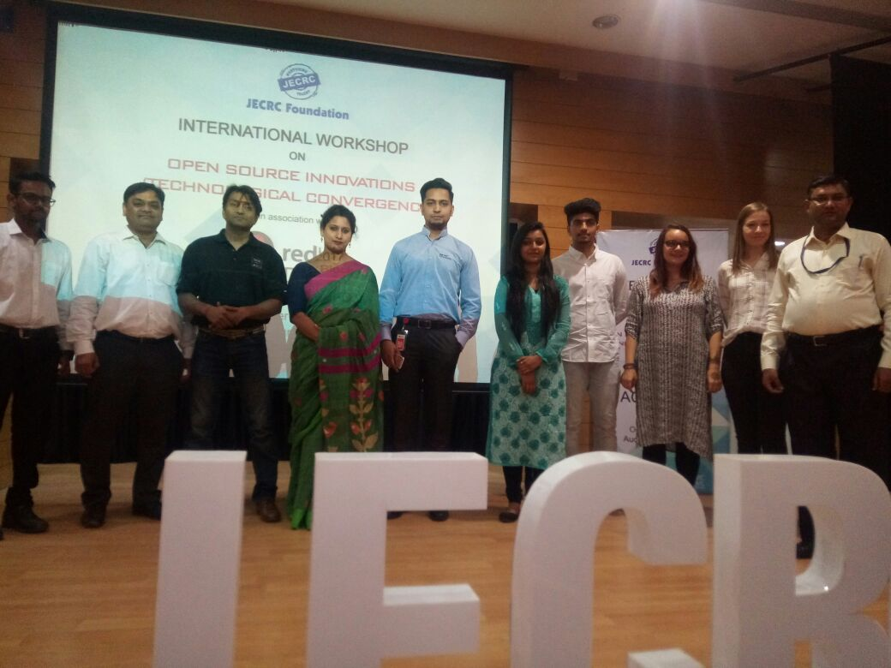

2. A workshop on **Sensor Botix Technology was organized by Techienest,Jaipur in association of ECE Department on 07th April, 2017.**

**3. A two days seminar organized by Huawei Authorized Network Academy (HANA) to make students aware of emerging wireless technologies from 29th to 30th July, 2017.**

**4. A seminar organized by Aptron India, Gurgaon to make students aware of Embedded systems, IOT and Microcontrollers on 09th Feb., 2017.**

**5.** **Mr. Anshul Gupta (Team Lead, Database- Infosys Technologies) visited ECE department and interacted with second and third year students.He briefed about them about functioning of IT Companies and various emerging domains. Students cleared their apprehensions about their career on 12th March, 2017.**

**6. An INDUSTRIAL VISIT organized at Genus Power Infrastructures Ltd., for second year students on 15th Feb., 2018.** The objective of Industrial Visit was to make aware the students about concepts and working of latest digital and smart eelectricity meters such as multi-functional single phase and three phase, Pre-Payment Meters etc.

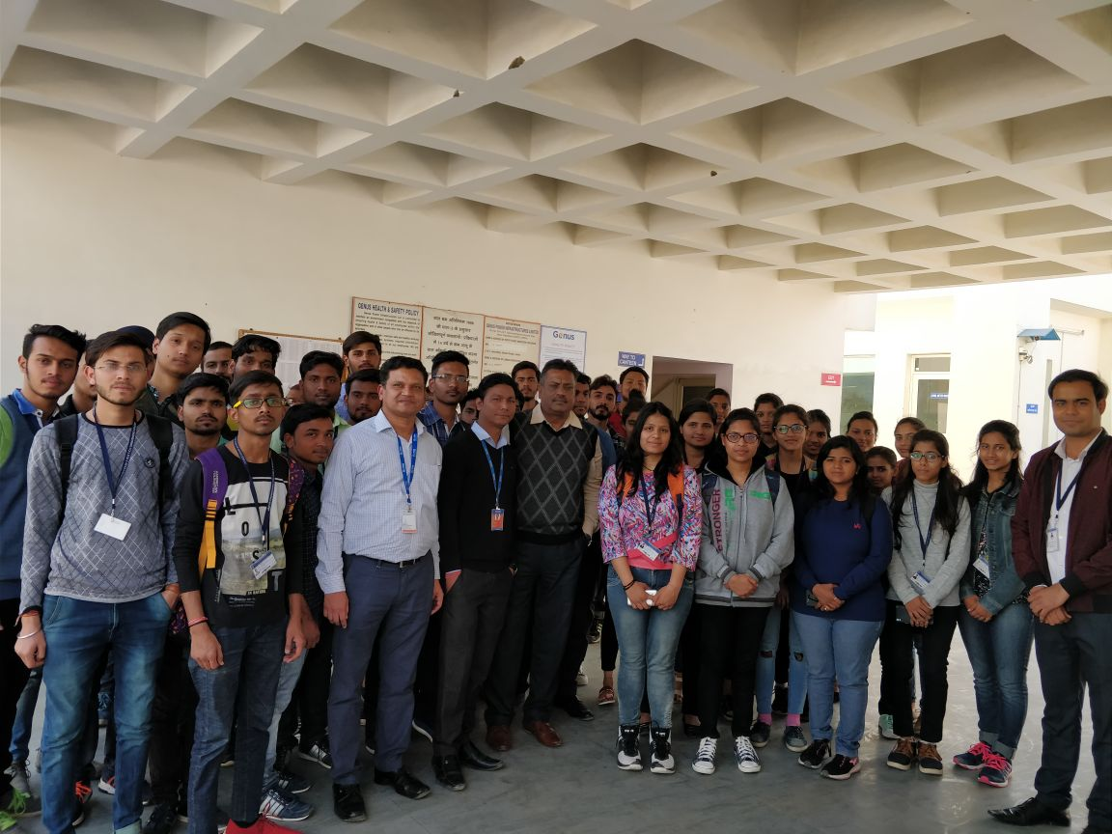

**7. An INDUSTRIAL VISIT organized at Tesca Technologies Pvt. Ltd., Ramchandrapura, Sitapura, Jaipur for Third year students on 17th Jan., 2018.** The objective of Industrial Visit was to make aware the students about concepts and working of latest Analog and Digital Test, Measuring Equipments etc. They will also be made aware of technologies used in developing Robotics, Power Electronics equipments and Power Supplies.